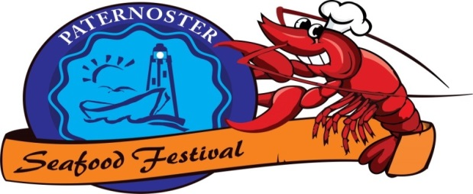
PATERNOSTER SEAFOOD FESTIVAL
30 NOVEMBER 2013

08HOO Touchies on beach @ Paternoster Fish market.
09H00 Kiddies entertainment.
Stalls open.
Mountain Bike race starts @ Fish market, through the town and Tietiesbaai Resort and ends @ Fish market
Fun run starts @ Tietiesbaai Resort gate along the sea to the Fish market.
Horse riding and Kayaking on the beach.
10H00 Tou trek on beach
11H00 Beer tent opens
12H00 Stage activities
Prize-giving for all sport activities
Various artists through the day on the stage
AWESOME PRIZES TO WIN !!!!!!!!!!
Come and enjoy a day full of sun, activities and Seafood in Paternoster!!!!!

